Location Reece
Production Title: Cadburys Dairy Milk
Producer: Emily Hales
Director: Emily Hales
Location: 21 Spencer Garden, London, Eltham, SE9 6LX
Date: 8/2/11
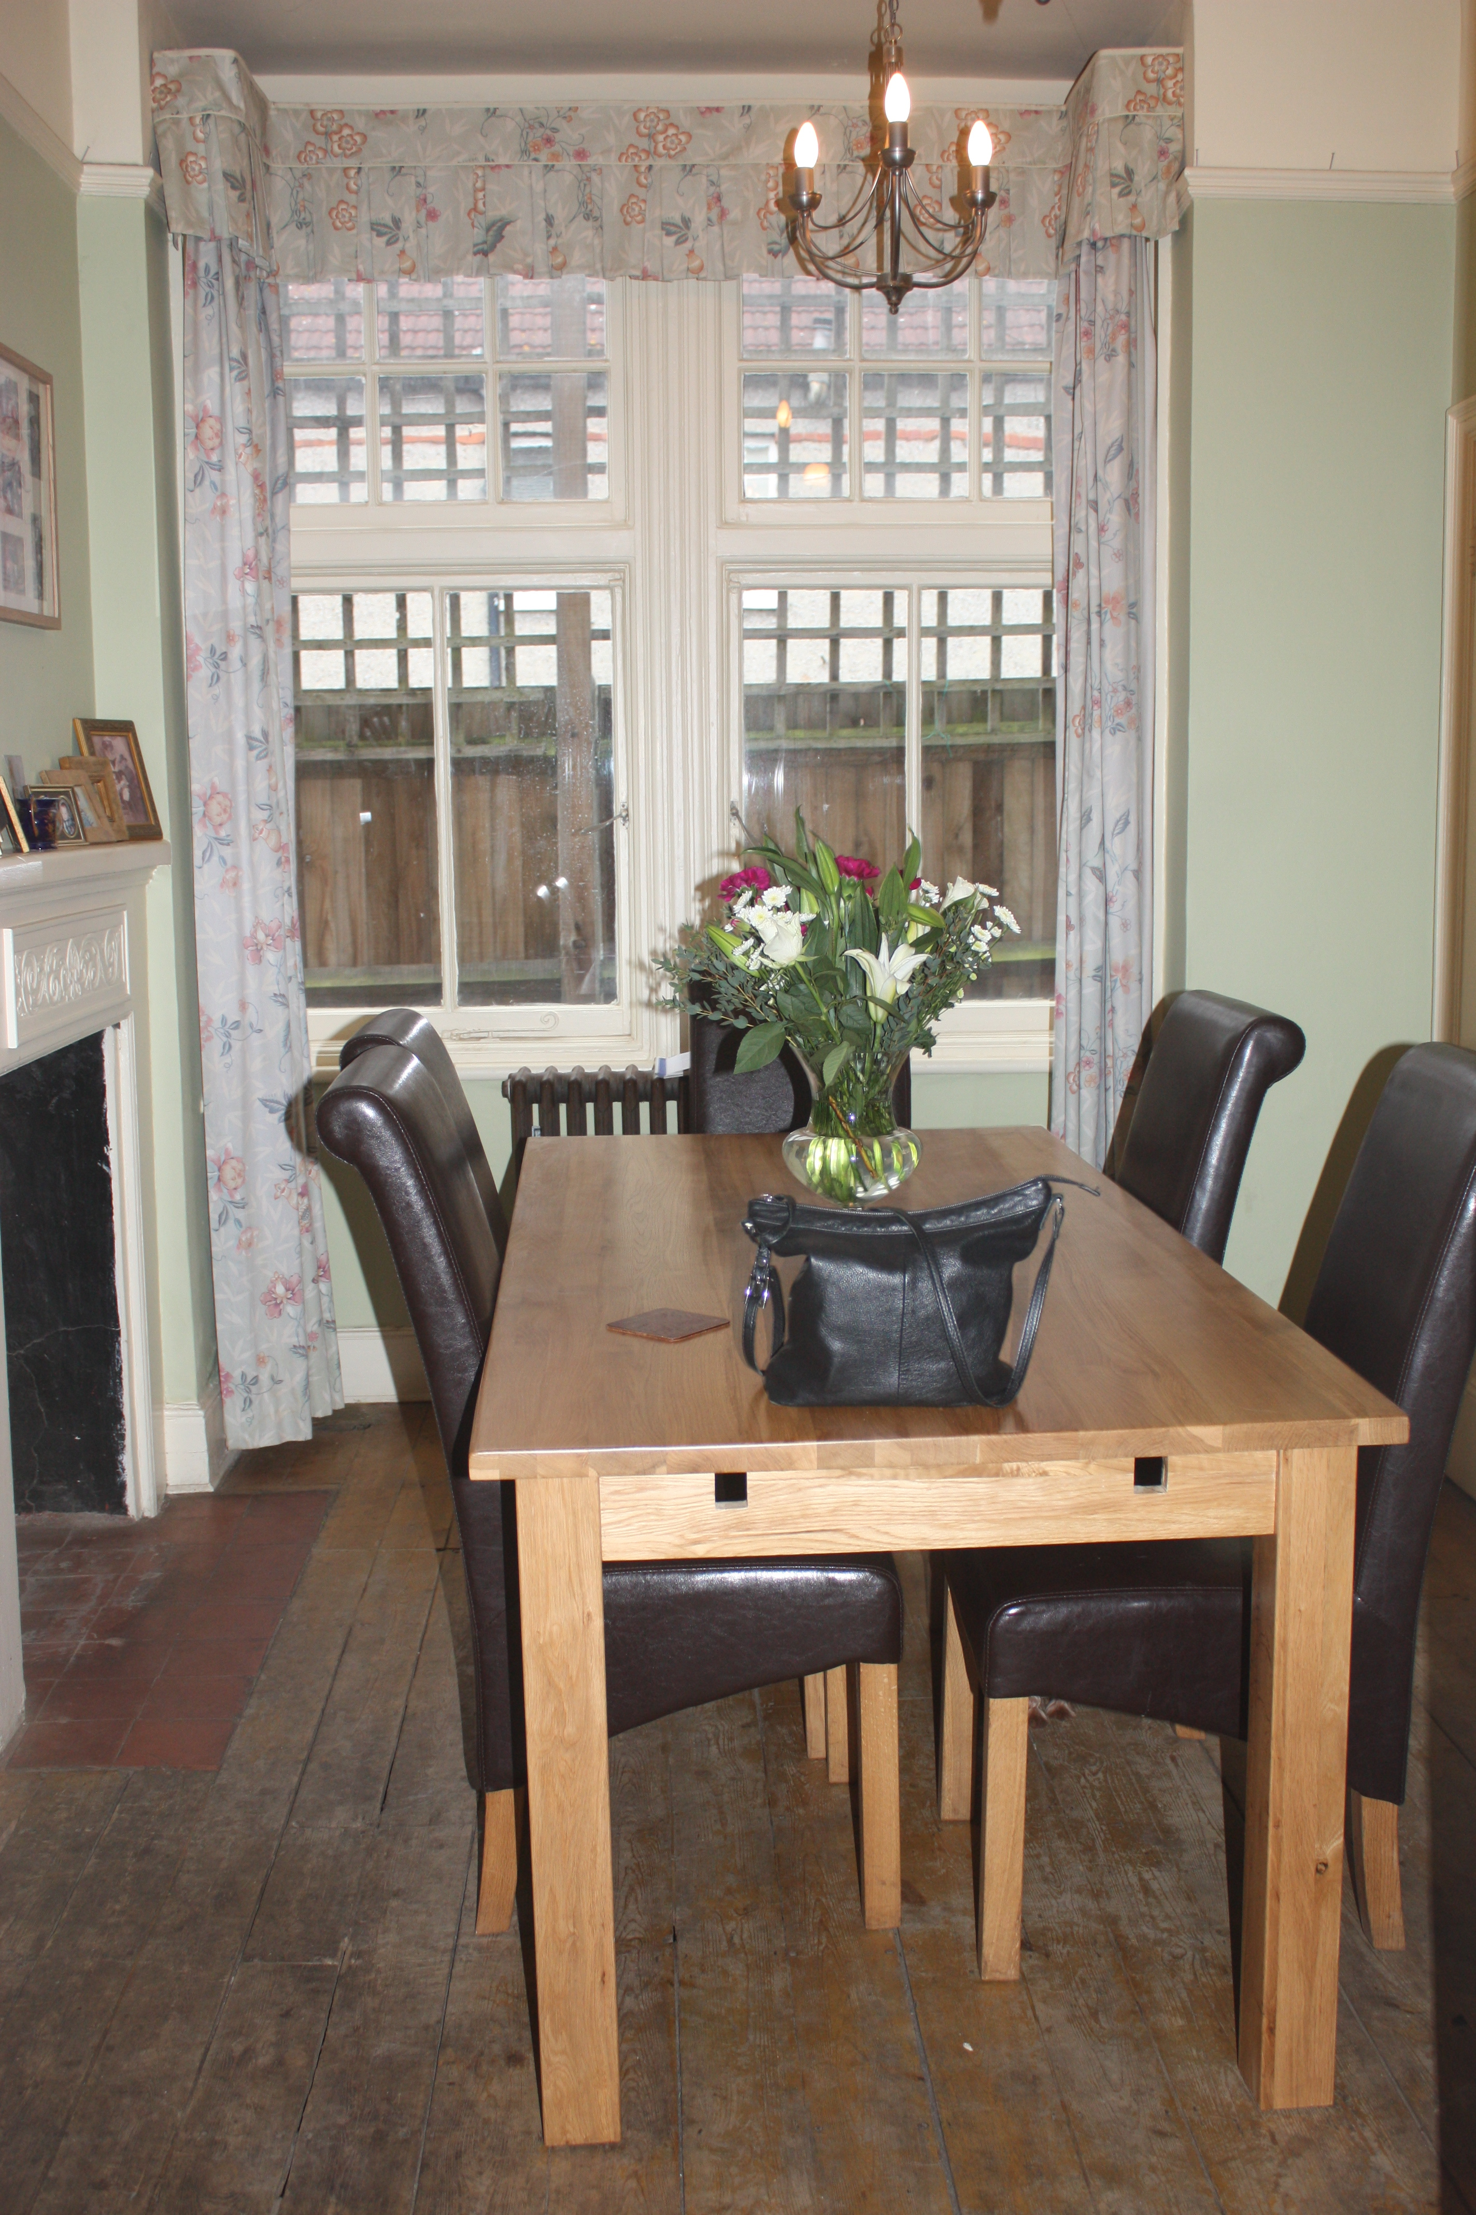
This location is the location were the bored actor gets the Cadburys Dairy Milk, this shot is critically because it actually shows the product and the idea and the moral story of the advert. This is in shot 11, and again the bored actor is only filmed here.
Problems worth noting:
- Wooden floor, meaning slippery if water was to be spilled.
- Not enough space because of big objects in the way, actors/crew could get injured.
- Fire exited being blocked in small spaces, hard to escape.

