Location Reece
Production Title: Cadburys Dairy Milk
Producer: Emily Hales
Director: Emily Hales
Location: 21 Spencer Garden, London, Eltham, SE9 6LX
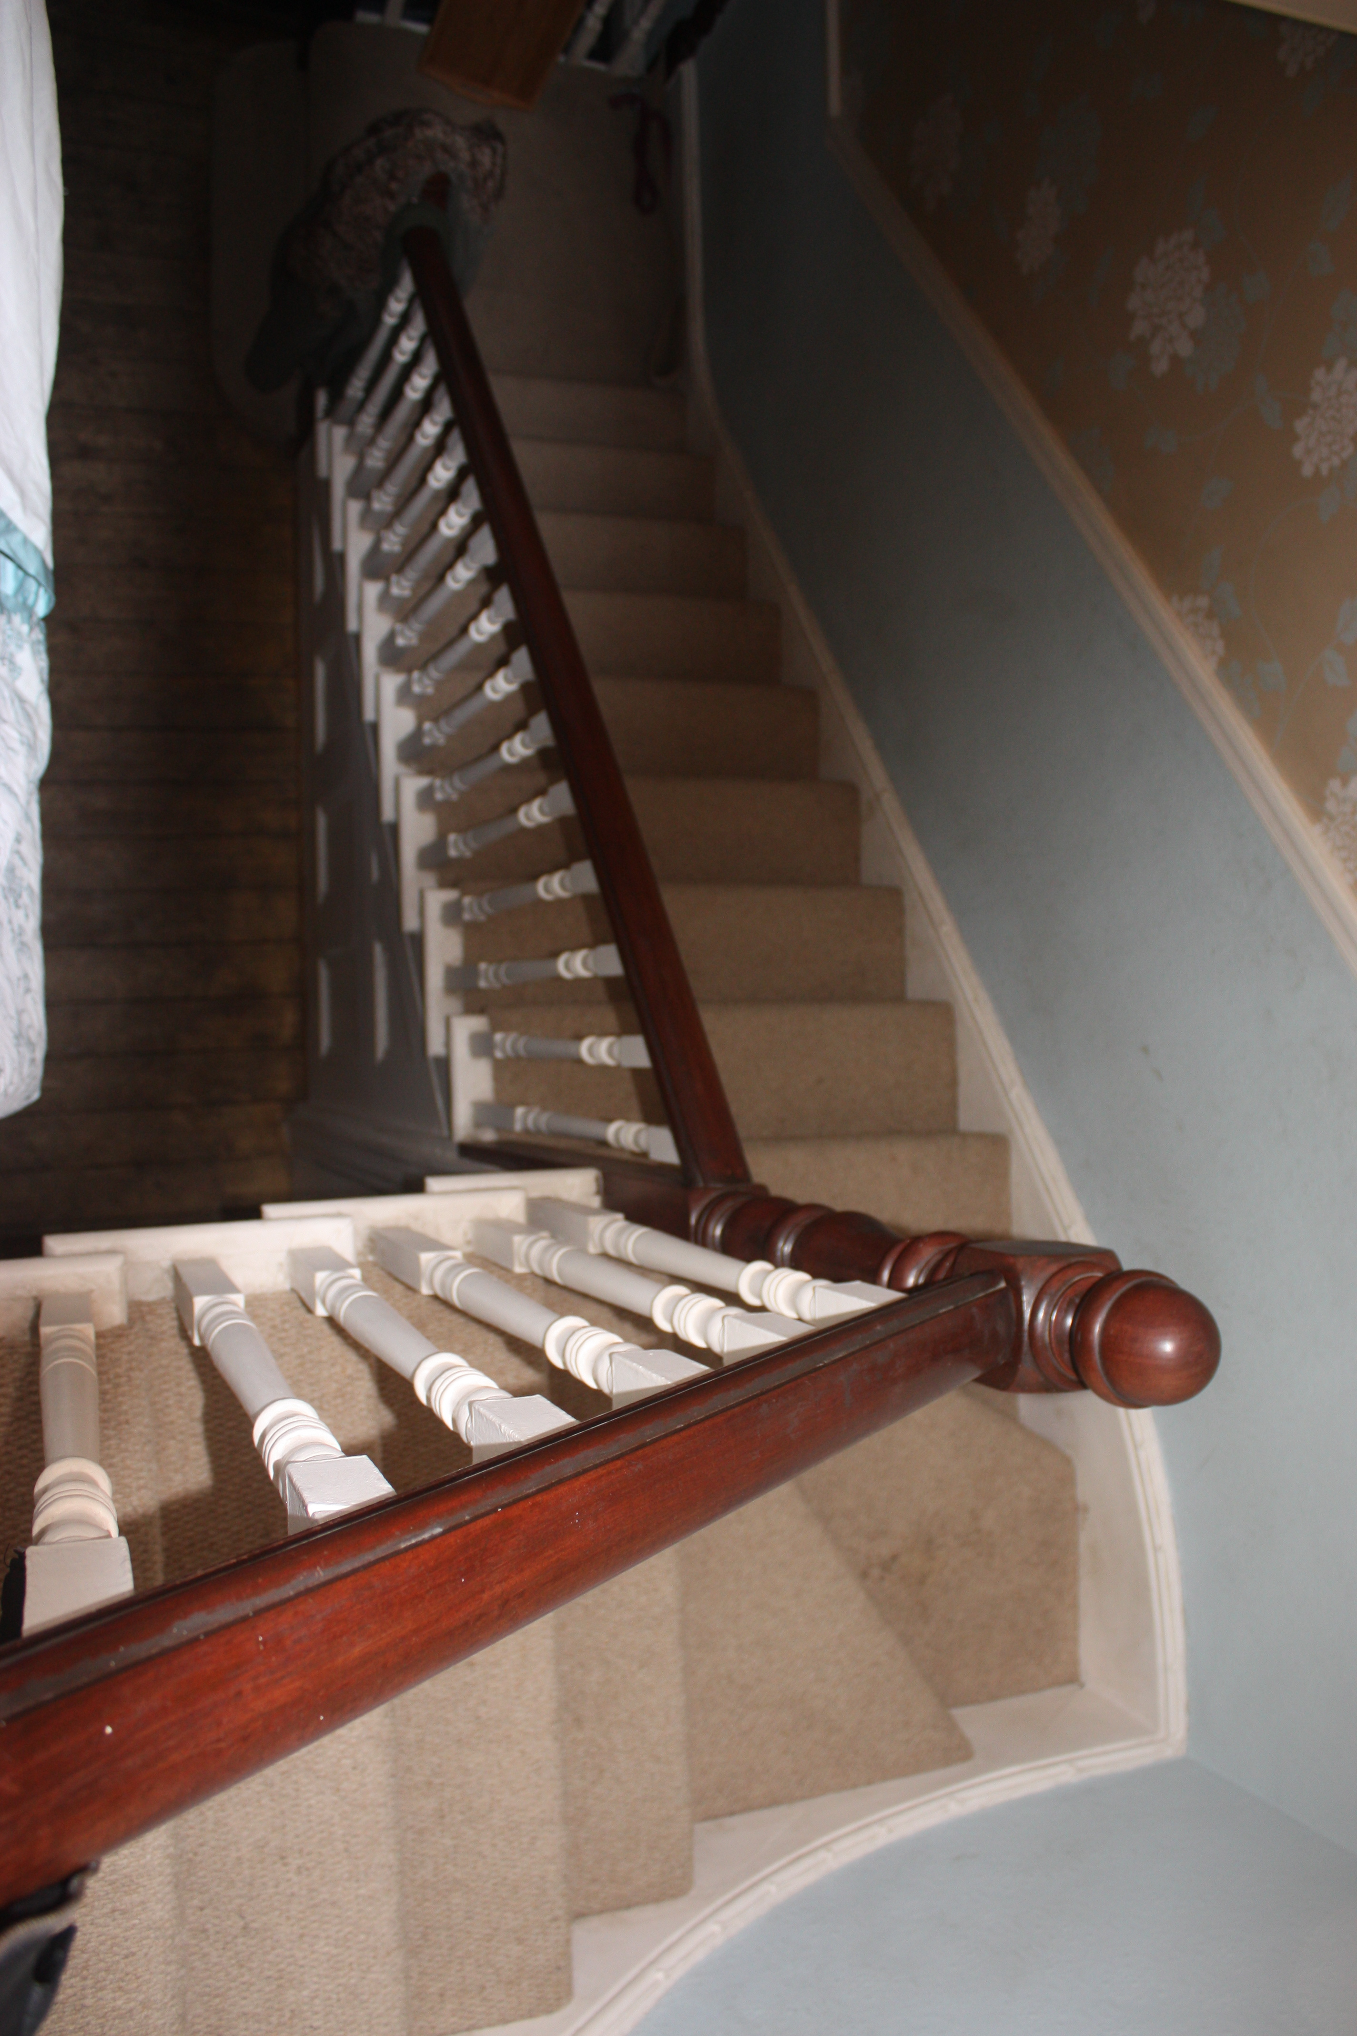
Date: 8/2/11

Problems worth noting:
- Tripping and falling on objects on the stairs.
- Slipping on stairs because of the speed of the actor running.
This location is the location of when the bored character thinks of an idea and rushes down the stairs, this is in shot 10. This shot is critically because it shows what the characters plan is and why about the planning is accruing. Only the bored friend is filmed here as they think of the plan.

