Location Reece

Production Title: Cadburys Dairy Milk

Producer: Emily Hales

Director: Emily Hales

Location: 21 Spencer Garden, London, Eltham, SE9 6LX

Date: 8/2/11

This location is were the character of the bored friend thinks of an idea this is in shot 9, and rushes towards the stairs. This only holds one character, the will be This location is were the character of the bored friend thinks of an idea this is in shot 9, and rushes towards the stairs. This only holds one character, the will be about 6 seconds on the footage.
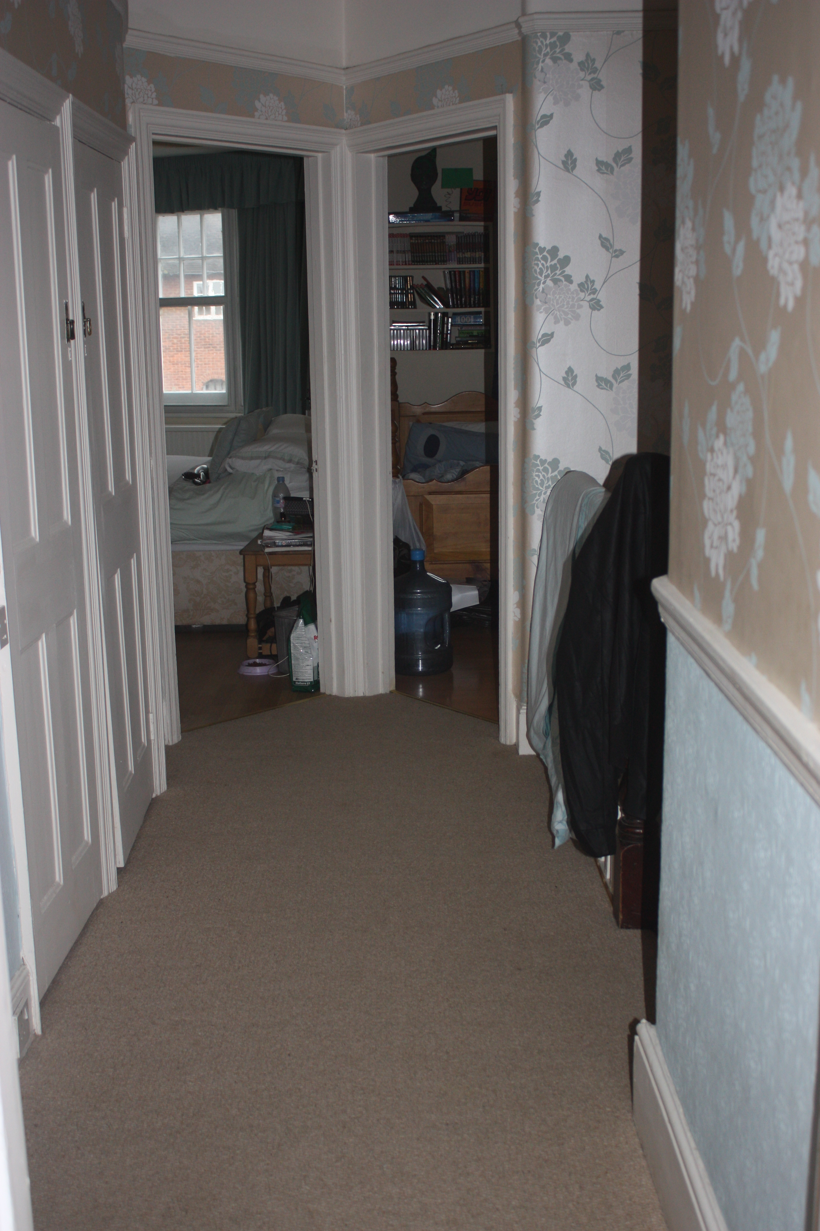

Problems worth noting
- Objects on floor, tripping because of the speed of the character.

