Materials I will be using for my production
Ill be using images when it comes to editing, such as the half and a glass full logo to be able to let the audience know the whole advert. I will be getting the image from goggle and importing it to be able to edit the image into my footage. For my Location Reece, I took the photos myself.
Ill also be using music soundtracks in my advert. Ill be able to find the right soundtrack by downloading a soundtrack from the Internet or from I tunes, however most of the sound is coming from the bass guitar.
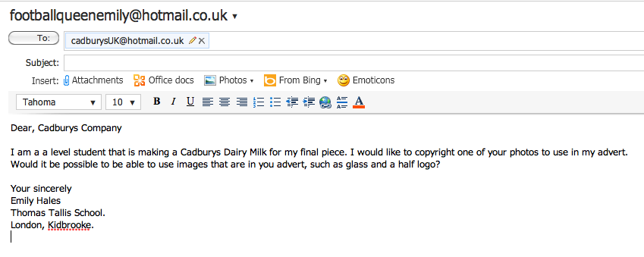
As I am copyrighting the soundtrack and images from the Internet, I will need permission to be able to use these materials, and to gain that permission I am going to use the photos, and write to them to tell them ive used them.

List of Materials
- Soundtrack/Images
- Cadburys Dairy Milk Chocolate Bar
- Bass Guitar
- Pillow

